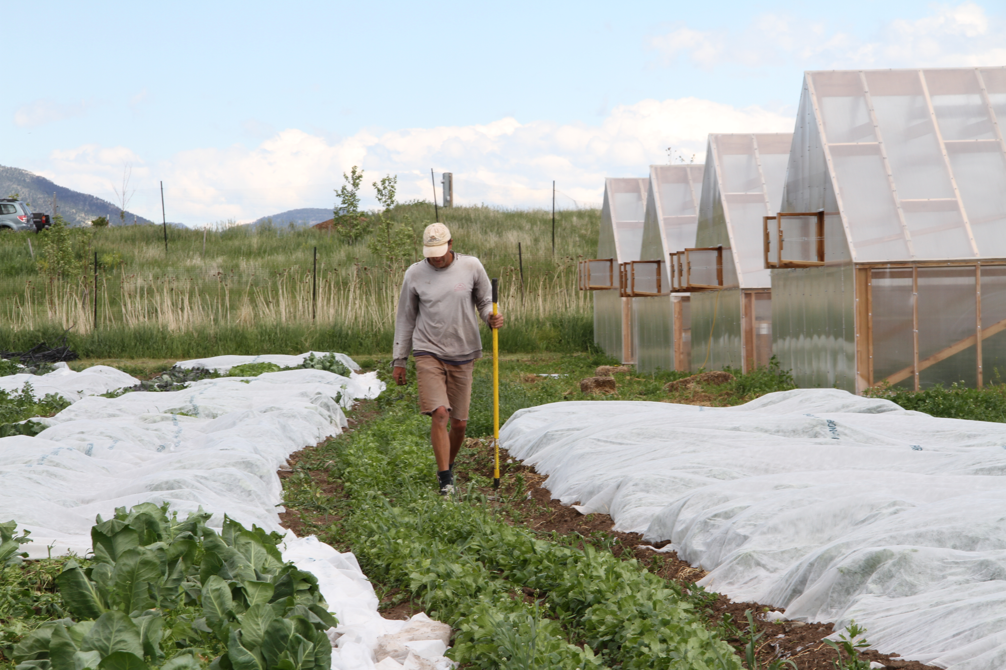

**Three Hearts Farm 2014 CSA Registration Form**

Mail this form with your payment to:

**Three Hearts Farm, 2111 Love Lane, Bozeman, MT 59718**

Checks can be made out to ***Three Hearts Farm*** and upon receipt of payment we will send you a confirmation email.

**CSA Options**

**( ) Full Season $600**

**( ) Holiday Share $210**

**Pick up Options**

**( ) Hands-on Option-**pick up your share at the farm

**( ) Market Option-**pick up your share in town

**Payment Plan**

Your share is reserved on receipt of this form with your payment. Shares are available on a first come, first serve basis. Cancellations prior to May 1st will be refunded minus 10% of the share cost. Checks will not be deposited until the date written on the check. We want everyone to be able to be able to access the freshest, healthiest produce available so if none of these payment plans work for you contact us and we will work something out.

**( ) One time payment-** enclose check for full amount with today’s date

**( ) Two payments**- enclose two checks of equal amounts, one dated today, one dated May 1st

**( ) Three payments-** enclose three checks of equal amounts, one dated today, one dated April 1st, and one dated May 1st

**Add Ons**

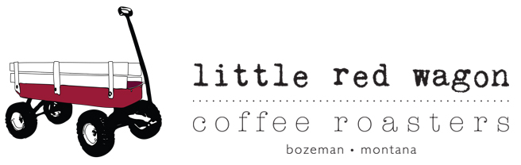

Fresh, locally-roasted, artisan coffee, using high quality, seasonal, single origin coffees from around the world.

With Little Red Wagon Coffee, you get delicious coffee each week, and you’ll join a coffee community. We have a satisfaction guarantee: if you're not 100% satisfied, we'll swap your beans for another option for you to try.

Weekly Options:

6 oz coffee/jar - $6

**( ) Total: $120**

12 oz coffee/jar - $12

**( ) Total: $240**

24 oz coffee/jar - $24

**( ) Total: $480**

We’ll deliver your coffee, each week with your box of fresh veggies

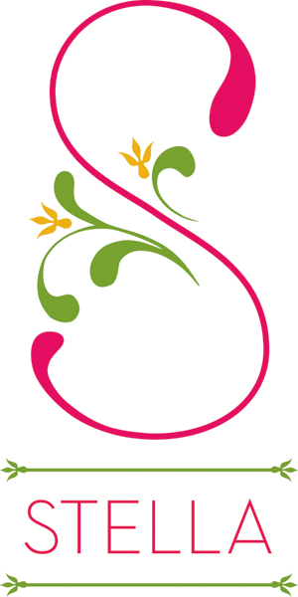

**Stella Jams**

Small batch jams, preserves and chutneys using, made in Bozeman, MT. Stella sources only sustainably-grown, chemical-free, locally produced fruit, veggies and herbs for the best-tasting, pleasantly-surprising combinations of flavors. .

Jam offerings will change with the season, but some flavors include: Flathead Cherry/Rosemary; Strawberry/Rhubarb/Thyme;

*Modern Tastes with Traditional Methods*

Options:

4 oz jar each week - $5

**( ) Total: $100**

4 oz jar every other week - $5

**( ) Total: $50**

8 oz jar each week- $8

**( ) Total: $160**

8 oz jar every other week - $8

**( ) Total: $80**

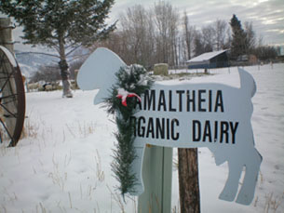

Amaltheia Organic Dairy is a sustainable, organic company that makes organic goat cheeses.  We have been making cheese for 12 years and have three American Cheese Society Competition Award-Winning Cheeses.  We utilize all of our by-products and now have organic whey-fed pork to sell - as well as organic vegetables and composted manure.

8 oz Plain Chevre- $4.60

**( ) Total: $92**

8 oz Smoked Chevre - $4.75

**( ) Total: $95**

8 oz Roasted Garlic & Chive Chevre - $4.75

**( ) Total: $95**

8 oz Whole Milk Ricotta - $4.75

**( ) Total: $95**

8 oz Feta - $5.25

**( ) Total: $105**

Milker’s Mix

20 weeks of various cheeses, 8 oz each week

**( ) Total: $95**

**Shareholder Information**

**Name(include names of all members if sharing a subscription)**

**Address**

**Phone Email**

**Have you been a CSA Member before? Yes ( ) No ( )**

**If yes, which CSA farm?**

**How did you hear about Three Hearts Farm?**